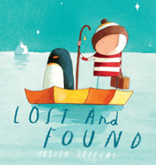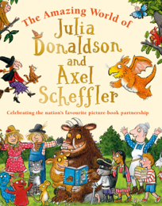 Year 1/2 Summer 2 Curriculum Overview

**Our class libraries have been replenished with a range of new books so this half term we will be sharing books from different authors.**

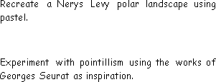

**Science**

**Growing Up**

**Are there patterns between the life cycles of different animals?**

* Identify parents and their offspring.
* Describe the life cycle of humans and some animals.
* compare to the habitat of the rainforest?

**Art/Design Technology**

**Sculpture and 3D: Clay Houses**

* Begin to shape and decorate clay, create a pinch

pot, design and create a clay tile with house features.

* Use hands and tools to develop basic skills when

cutting, shaping and joining materials.

**PSHE**

**Unit:** Changing Me

* My changing body and feelings. What is self-image?
* Changing ways of thinking.

**Religious Education**

**Unit:** Judaism

**What is the best way for**

**a Jew to show commitment to God?**

What do you think is God’s biggest

Achievement?

**Mathematics**

**Focus:** Fractions, Time, Mass and Capacity

* Recognise half, quarters, thirds and three quarters.
* Tell time to the hour, half an hour, quarter of an hour.
* Measure in different units.
* Complete the four operations using mass and capacity.

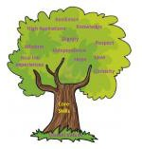

**PE**

**Athletics**

Develop running, jumping and

throwing skills.

**Striking and Fielding**

Develop skills for games such as

rounders and cricket.

**Music**

**Structure (Myths & Legends)**

Is it okay to sometimes give up?

* Create a structure with a

beginning, middle and end by

writing and playing rhythms.

Great Fire of London- Who was to blame for the Great Fire of London?

How can I demonstrate compassion?

* Know the events of the Great Fire of London.
* Know significant people from the time.

**Computing**

**Humanities**

**English**

**Text: Lila and the Secret Rain**

**Skills:**

* Use of first and third person
* Using conjunctions
* Past progressive tense
* Uplevelling vocabulary

**Data Handling**

**International Space Station – Data Handling**

* I Know how computers use data and are used to help humans.
* Online safety - To recognise that not everything is true.