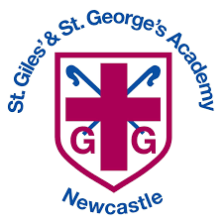


EYFS Nursery
Induction Booklet

Welcome to St. Giles’ and St George’s Academy

We are delighted to have you and your child join our school community at the very start of their learning journey. This booklet has been designed to help you understand what to expect in Nursery, from daily routines to the exciting activities that support your child’s development. Our aim is to create a safe, nurturing, and stimulating environment where every child feels happy, confident, and eager to learn. We look forward to working in partnership with you to ensure your child has a positive and rewarding start to their school experience.
We hope this booklet will contain the information you need for a smooth transition in to our school but if you do have any questions at all then please do not hesitate to contact us.

Tel: 01782 917640
Email: office@stgg.org.uk

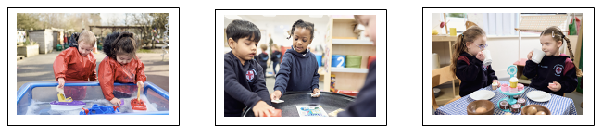

School Vision

Our community is inspired by our Christian values to enable all to flourish in mind, body, heart and spirit.

HE SET MY FEET ON A ROCK AND GAVE ME A FIRM PLACE TO STAND (PSALM 40 V. 2)

Curriculum Aims and Gospel Values

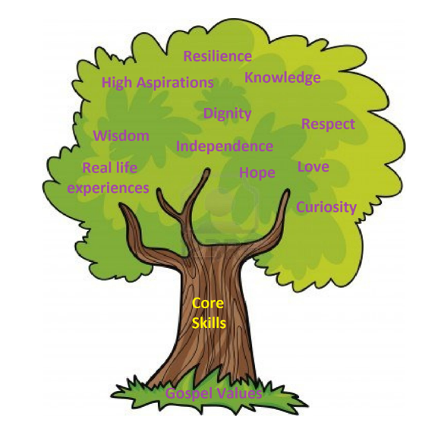

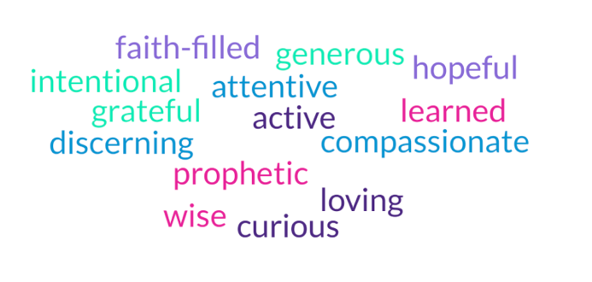

General Information






Mrs Fry
SENDCo
Mrs Wright
Assistant Principal,
EYFS Lead
Mrs Jones
Senior Assistant Principal
Mrs Pointon
Principal

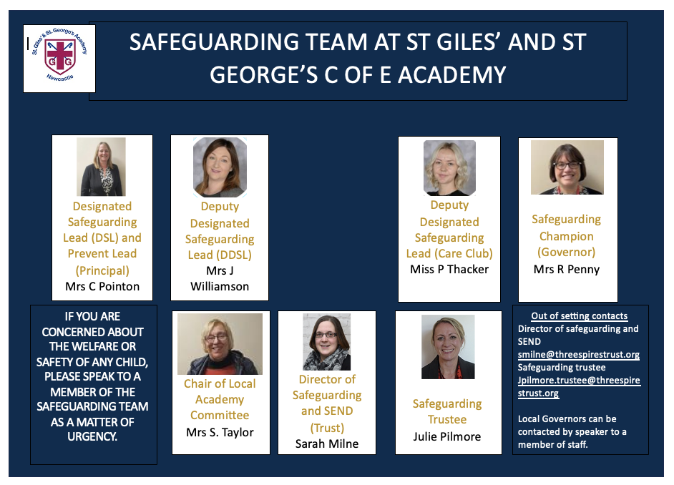

EYFS Staff





Miss Whyte
Teacher
Mrs Huckfield
Room Leader
Mrs Hissey
Teacher
Mrs Gray
Teacher
Mrs Wright
EYFS Lead, Teacher



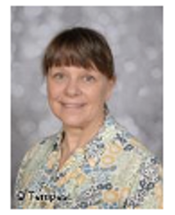


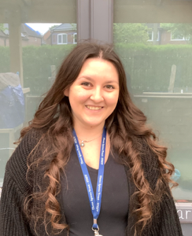
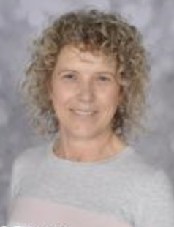

Miss Zyla
Learning Support Assistant
Miss Abi
Learning Support Assistant
Miss Maja
Early Years
Apprentice
Mrs Gibson
EY Teaching Assistant
Miss Greatbatch
EY Teaching Assistant
Mrs Stubbs
EY Teaching Assistant

Mrs Carter
EY Teaching Assistant

Our Early Years Department

Our Early Years Department consists of a Little Explorers room for ages 2-3, a Nursery room for ages 3-4, and two Reception classes, each led by qualified teachers/early years practitioners and supported by teaching assistants and apprentices.

The Early Years Framework is accessed by children from birth to 5 years of age and our provision caters for children at varying stages of their early years development.

We offer both funded places, private hours places or a combination. Working parents of children under the age of five are now entitled to 30 hours of government funded childcare a week. If you are not eligible for free childcare for working parents you may still be eligible for help towards childcare costs.

Check your eligibility here: www.childcarechoices.gov.uk

As well as this, all children aged three to four can still access 15 hours of government funded childcare under the universal offer, it doesn’t matter how much you work or how much you earn.

How to Apply for the Funding
Applying is simple and can be done entirely online through GOV.UK. Here’s how:
- Check your eligibility using the government’s childcare calculator at www.childcarechoices.gov.uk
- Apply online for a childcare code through your childcare account.
- Get your unique code and give it to St Giles’ and St George’s
- Apply before the deadline. You can apply up to 3 months before your child is eligible.
- Reconfirm every 3 months to keep receiving the funding.

Nursery Unit
Our Nursery unit consists of two classes; a 2-3 year olds room called Little Explorers and a 3-4 year olds room.

Little Explorers (ages 2-3)
Children can join our Little Explorers (2-3 years) the term following their 2nd birthday. We offer the following places:

15 hours | 30 hours funded  (Full School Day)
Mon – Fri  AM 8:50 – 11:50 or  PM 12:15-15:15 or  2 full days and 1 half day | Mon – Fri  8:50-15:15

If you are not eligible for the government free child care funding, children can still join our Little Explorers and each AM / PM (3hours) private hours session is charged at £15, sessions can be booked using the form included in the induction pack.

Nursery (ages 3-4)
Children can join the Nursery aged cohort (3-4 years) in the September after their 3rd birthday.

15 hours funded | 30 hours funded  (Full School Day)
Mon – Fri  AM 8:50 – 11:50 or  PM 12:15-15:15 or  2 full days and 1 half day | Mon – Fri  8:50-15:15

Any child allocated 15 hours government funding can pay for additional private hours wrap around AM or PM sessions, this is charged at a rate of £15 per additional session (3hours).

Additional private wrap around sessions must be pre-booked for the term using the booking form which is within the induction pack or available from a member of staff.

Wrap around charges are applied to each Arbor account weekly and must be cleared on time and in full.

What you will need each day:

- Backpack and coat
- 2 full spare changes of clothes (underwear, socks, t-shirt, jumper/hoodie, shorts/joggers)
- Water bottle (preferably filled with water each day)
- Lunch box (if applicable)
- Wellington boots
- Carrier bag (for any wet/soiled clothing)
- Baby wipes, nappies and nappy sacks (if applicable)
- Sun hat and sunscreen in summer
- Hat and mittens in winter

Please ensure ALL clothing and belongings are named. This helps us to return all items to the right owner.

Before and After School Club

Our before and after school Care Club offers wrap around care outside of the normal school day for Nursery and Little Explorers.
The times are 7:30am – 8:50am and 3:15-5:45pm.

Session | Cost
Before School
7:30-8:50 | £5.00
8:00-8:50 | £3.50
After School
3:15-4:15 | £3.50
3:15-5:45 | £9.50
Whole Day
7:30-8:50 and 3:15-5:45 | £13.00

Places at our Before and After School Club do not need to be booked in advance you simply need to inform the class teacher on the day or via Dojo if you require after school care club. Charges are applied to your account after your child has attended and must be paid promptly and in full.

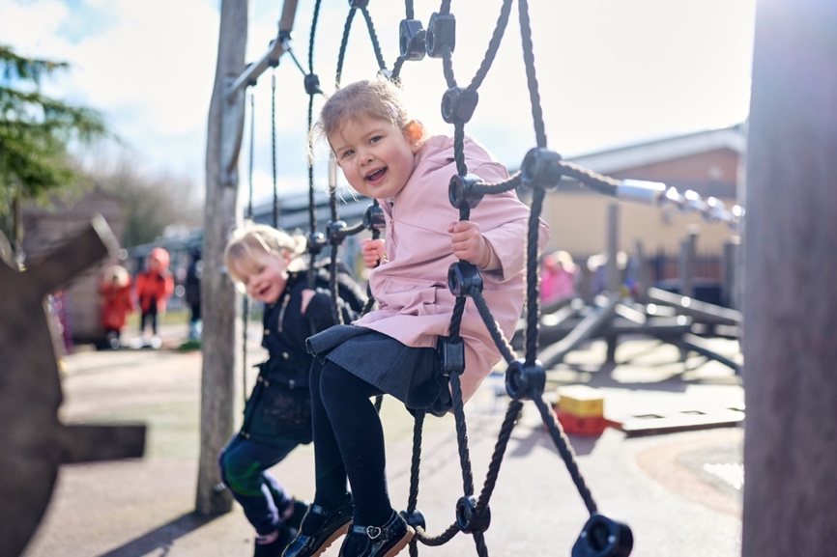

Little Explorers and Nursery Consumables

Government funding for the 15 or 30 hour entitlement does not cover consumables, so providers are able to ask parents to pay for these things and invoices will be broken down for transparency as follows:
- The free entitlement hours
- Additional private paid hours
- Food charges
- Non-food consumables charges
- Activities charge
Included within the free entitlement hours:
- The Nursery Milk Scheme milk entitlement for all children under 5
- The school fruit and vegetable scheme entitlement for a fresh fruit or vegetable snack each day
- Fresh drinking water available all day
A Consumables Charge of £0.75 per day applies to cover toileting supplies listed below, alternatively parents can supply their own.
- Nappies
- Wipes
- Nappy Sacks
Lunchtime meals are not included within the free entitlement hours and these must be provided from home or ordered from school at £2.75 each.

EYFS children have the opportunity to enjoy special activities from visitors into school, to make visits within the local community and to go on trips further afield. All of these activities are chargeable and details for any planned visitors or trip activities will be sent to parents in the prior half term.

Uniform

All of our Little Explorers and Nursery children wear our school PE uniform to school every day, to ensure that they are comfortable whilst learning and to support their independence in getting themselves dressed/undressed each day.


Our uniform is available from Smart School Uniform, located on Hassall Street in Newcastle town centre or via their website, following the QR code. Alternatively, you can purchase unbranded supermarket versions.

Our uniform comprises of:
Navy Shorts or joggers / leggings
Navy t-shirt or a school PE t-shirt
Navy jumper/hoodie (no zips) or a school PE hoodie
Trainers
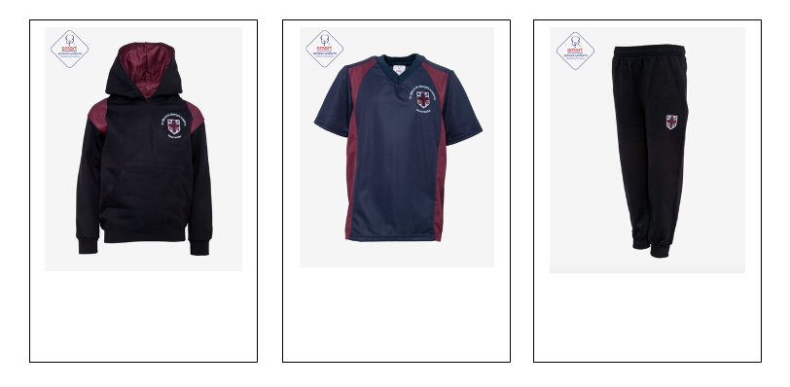
Long hair (shoulder length or longer) must be tied up at all times.

All earrings must be removed for PE sessions.
Please ensure ALL clothing and belongings are named

EYFS Safer Eating

In line with EYFS requirements, Benedicts Law and health and safety guidance, we have clear systems in place to keep all children with allergies safe. All EYFS staff and lunchtime support staff are Paediatric First Aid trained, and receive regular training to ensure they can recognise and respond promptly to allergic reactions, including anaphylaxis. Where required, individual healthcare plans are created, regularly reviewed, and carefully shared with relevant staff to ensure everyone is fully informed.
We work closely with parents to collect clear and accurate information about any allergies or medical conditions, and this is communicated to all appropriate staff. The school ensures that emergency medication, such as adrenaline auto-injectors (AAIs), is stored safely and is readily accessible when needed.
Food provided in school is carefully managed, with steps taken to avoid cross-contamination and to ensure that all allergen information is known, followed, and communicated effectively.
Staff closely supervise all eating times, supporting children to develop safe eating habits and good manners in a calm and positive environment.
If your child has special dietary requirements, it is essential that the allergy forms included in the induction pack are completed and returned to the school office by Friday 3rd July, along with medical documentation which clearly outlines your child’s food allergies/ intolerances, and must be from a medical Doctor, Dietitian or Specialist Nurse.

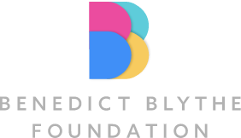

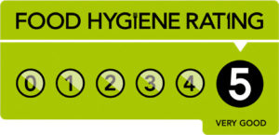

Lunch and Snack Time

All children in EYFS receive a free piece of fruit or vegetable at snack time. They will also receive free milk each day, until the half term after they turn 5. Parents do not need to provide snacks.

Little Explorers and Little Learners children who are staying for a full day are able to purchase a school meal at £2.75 ordered via Arbor and must be ordered before 8am each day or provide a lunchbox from home.

Parents do not need to provide snacks.

Information from our school meal provider can be found here.



Fresh drinking water can be offered by school throughout the day to drink, and we encourage only water to be sent in water bottles from home.

Lunchboxes
You may provide your child with their own packed lunch from home and it should be balanced and nutritious.

Packed lunches should not contain nuts, sweets, chocolate, chewing gum, fizzy drinks, fruit and vegetables that are not chopped as per the above guidance or meat on the bone.
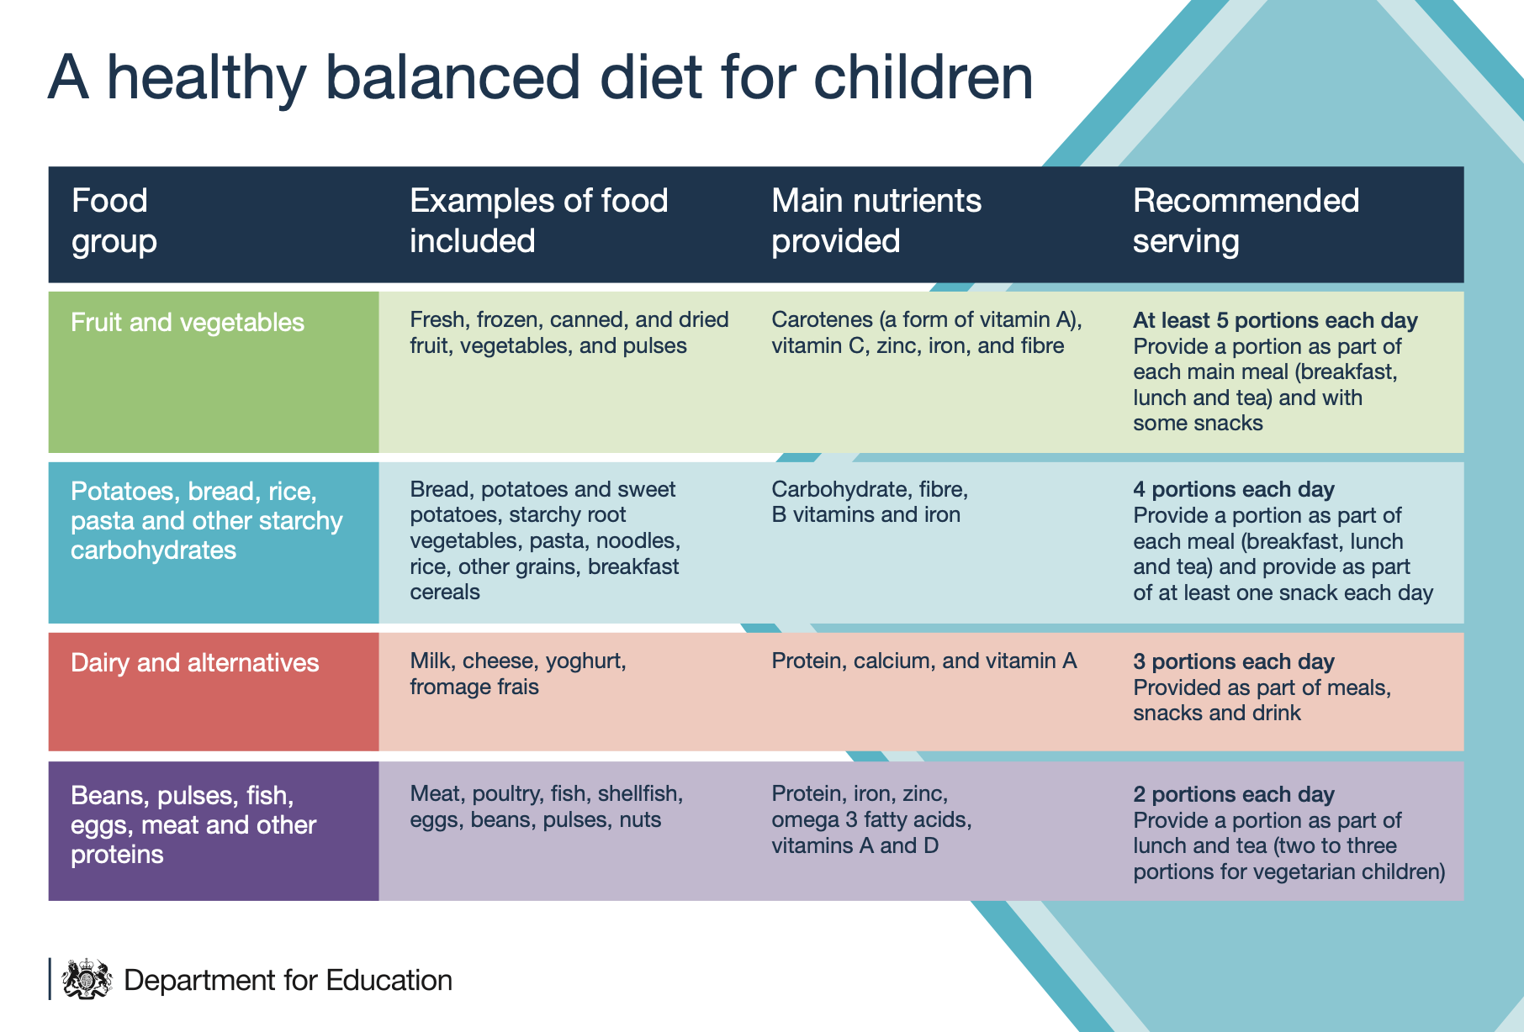
.

When preparing your child’s lunchbox please follow the advice below to minimize choking hazards:
- Large fruit should be cut into slices not chunks
- Small fruits e.g. grapes, berries, cherry tomatoes should be cut lengthways in quarters
- Vegetables should be cut lengthways in batons
- Sausages should be cut lengthways in short batons and skin removed
- Meat must be removed from the bones with skin removed, and then cut into thin strips

Please pack foods that can safely be kept at room temperature as there is no refrigerated area for storing food brought from home, alternatively you can add an ice cooler block to your lunch packs each day.

EYFS Safe Sleeping

Following guidance from The Lullaby Trust, NHS, and EYFS requirements we follow clear, safe sleep practice where sleep routines are carefully managed and safety is prioritised.
- Children are provided with a safe sleep mat that meet safety standards
- Staff check that bedding and mattresses are used correctly and safely
- Children are regularly supervised while sleeping—staff will check on them frequently and record
- Where relevant children are placed in safe positions to sleep, and all children are kept comfortable—not too hot or cold
- Comfort items (like soft toys) are used appropriately and safely
Families will receive an update via Dojo regarding sleep where relevant.

Quite time and sleep time is scheduled into the Little Explorers timetable in the afternoon session, please discuss your child’s sleep requirements and routines with the Little Explorers Room Leader.

Rainbow Behaviour Policy

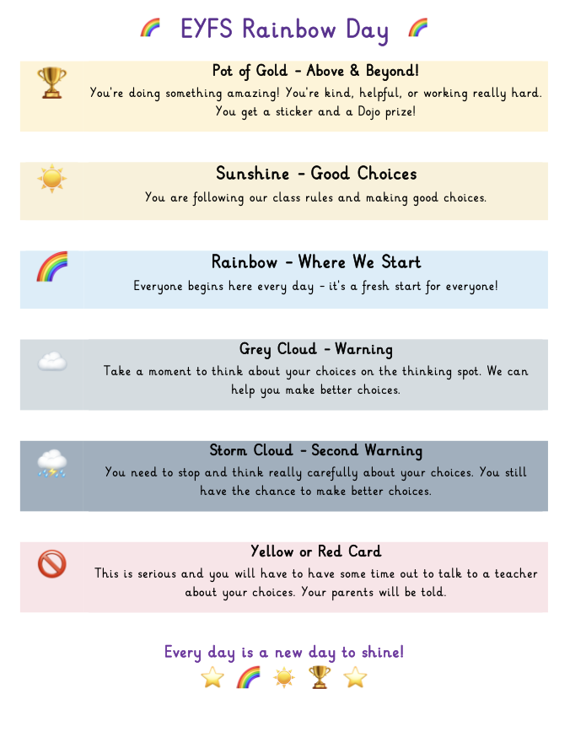

Getting Nursery Ready

We understand that all children develop at their own pace, and that we’re all learning from birth. There are some key communication, personal, social, emotional and physical skills that most children will develop by the time they join Nursery and practicing these at home will help your child feel confident starting school, settle quickly into their new routines and engage positively with learning.

Being Independent key skills:
- Wash their hands
- Say when they need the toilet and are using the toilet independently by the time they are 3 and moving into our Nursery Class
- Put on their own coat
- Use a spoon
- Choose what they would like to play with
- Ask for help when needed
- Tell others how they are feeling
- Join in with activities others are doing
- Saying goodbye to familiar adults and managing spending time apart
- Establish healthy routines at home, bedtime, tooth brushing, limiting screen time

Special Educational Needs
If you have any concerns about your child’s progress, or if your child has special educational needs or disabilities (SEND), developmental differences, or delays, please speak to your child’s class teacher as soon as possible. We encourage you to share as much information as you can about your child’s development, their needs, what motivates them, any potential triggers for difficulties, and strategies that have been effective.
The Early Years Foundation Stage is committed to meeting the needs of every child. If staff identify any areas that may require additional support or attention, they will inform you and arrange to discuss this with you in confidence. Where appropriate, your child may receive additional support through targeted interventions or with the involvement of external agencies.
Mrs Fry is our Special Educational Needs and Disabilities Coordinator (SENDCo). She works closely with EYFS staff and meets with them regularly to support children with individual needs.

Social, Emotional and Mental Health

The emotional wellbeing of our children is paramount, ensuring they are settled and happy is our first priority. The school has a school counsellor, mindfulness spaces, sensory room, Emotional Literacy Support Assistant (ELSA), prayer garden and therapy trained school dog Harriet, which are all used to support the social, emotional and mental health of our children.
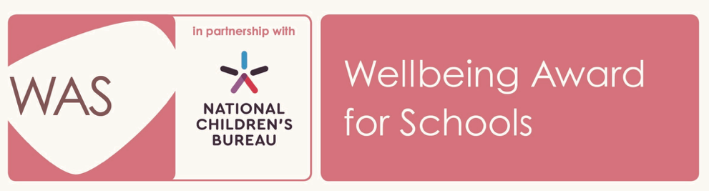

School Site Rules
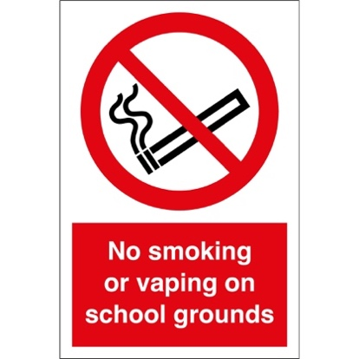

Please note that smoking or vaping is not permitted on site.



We also politely ask that you do not use mobile phones at the start or end of the day when bringing or collecting your child and that phones are not brought into the building during EYFS events for safeguarding reasons.

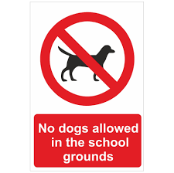

No dogs, except service animals, are allowed on the school grounds.


For health and safety reasons, we kindly request that children refrain from using the outdoor playground equipment and other outdoor resources before and after school.

The Early Years Curriculum

Our curriculum is tailored and planned to promote our children’s enthusiasm, curiosity, love of learning and personal development. The children are provided with a range of purposeful independent learning opportunities through play and direct teaching. The curriculum is planned through the seven areas of learning and development:

Prime Areas

Communication and Language development involves giving children opportunities to experience a rich language environment and to develop listening, attention, understanding and communication skills.

Physical Development involves providing opportunities for children to be active and interactive, to develop their coordination, strength and balance. Children will develop their fine and gross motor skills and gain the knowledge and understanding of how to live a healthy, active lifestyle.

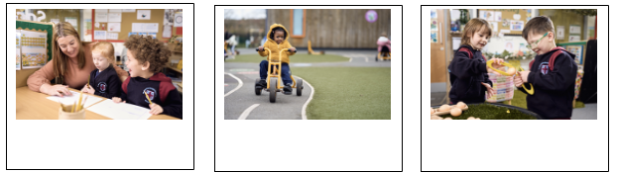
Personal, Social and Emotional development involves supporting children to understand and manage their own and others’ emotions, to form positive relationships with their peers and develop respect for others. They will learn about boundaries and behaviour expectations as well as developing a positive sense of themselves.

The Early Years Curriculum

Specific Areas

Literacy involves supporting children to develop a life-long love of reading. Children will join in with rhymes, songs and shared story times and experience a wide range of different reading materials to ignite their interests. Children will learn to link sounds and letters with Super Sonic Phonic Friends and they will apply these skills into writing.

Mathematics involves developing their understanding of number, quantity, shape and space. Children will learn to count confidently and develop a deep understanding of number, relationships between them and the patterns within these numbers.

Understanding the World supports children to make sense
of their expanding world and their place within it through nurturing their wonder, curiosity, and providing opportunities to explore people, places, technology and the environment.

Expressive arts and design fosters imagination, curiosity, creativity, and provides opportunities to improvise, collaborate, and interact. Children will explore and play with a wide range of media and materials to share their ideas and feelings through a variety of activities including art, D&T, music, dance and role-play.

The Early Years Curriculum
Assessment

Assessment in EYFS is primarily based on what teachers and practitioners know about the child from their own professional knowledge, observations, and interactions.
All children will have a baseline assessment upon entry, which will include Early Communication Screening.

Statutory Assessments include:
Two Year Checks
When a child is aged between two and three, and usually coinciding with the Health Visitor completing the Healthy Child Programme health and development review, practitioners will review the child’s progress and provide parents/carers with a short, written summary of the child’s development.

Summative Assessment at the end of Reception:
At the end of the Reception year, teachers complete the EYFS profile for each child. Pupils are assessed against the 17 early learning goals, indicating whether they are:
- Meeting expected levels of development, or
- Not yet reaching expected levels (‘emerging’)
If children have achieved all ELG’s in all three prime areas, as well as literacy and maths, they are said to have a Good Level of Development (GLD).

Throughout the year some of your child’s achievements and WOW moments will be collected and recorded in their Learning Journey. We also use an online assessment tool called Evidence Me. This allows us to observe and take photographs to link to the curriculum strands. Parents will receive updates from Evidence Me via Parent Share each fortnight.
You will also be informed of your child’s progress through school reports and parents’ evenings.
School Apps
www.classdojo.com
All communication and information sharing is via Class Dojo. EYFS events are added to the calendar each half term.
You will receive a Class Dojo QR Code in September to scan and join your child’s class. Only those with Parental Responsibility are permitted to join a child’s class.
For our Little Explorers and Nursery children you will receive daily updates regarding sleep, toileting and meals.



www.arbor-education.com
Arbor is used for booking parent’s evening appointments, signing up to after-school clubs, and includes your child’s profile which you can access and check all details are correct. Arbor is also used for payments relating to school trips and events, school meals, care club and wrap around charges.



www.evidence.me
Evidence Me is our online assessment tool, we use this to capture WOW moments in pictures/videos and link to the curriculum statements to build up a picture of each child’s strengths, interests and achievements and to guide our next steps. You will receive a sign-up email invitation for Evidence Me in September.

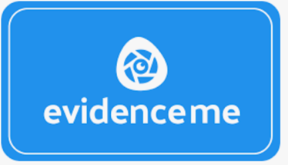

Pupil Premium

The (Early Years) Pupil Premium is a sum of money given to schools to support children. We strongly encourage all families to check if they are eligible as this support can make a meaningful difference to your child’s early education.

It is the school's responsibility to ensure that this money is spent on further supporting their education and wellbeing.
Support may include:
- Help funding school visits
- Uniform
- Equipment
- Extra in school support for your child
- Small group work with higher staff to child ratios

How do I know if I am eligible for free school meals?
Eligibility is based on certain criteria, such as income or benefits, and applying is quick and confidential.

Please contact the school office. All you need is your NI number, date of birth and child's details for an eligibility check to take place.

School and parents will receive confirmation through the post within 5-10 working days.

Parents as Partners

We would like to emphasise that by working in partnership we can make your child’s time even more successful and rewarding. Your child’s school planner clearly outlines our expectations of you as a parent to support your child at home and the standards you can expect from us as a school.

We will keep you informed of our learning activities via our curriculum overview document for each half term, through Class Dojo posts, on our social media, and via Evidence Me Parent Share.

Throughout the year we hold a variety of parental workshops, these workshops are very useful to help families understand our curriculum and to share ideas of how you can support your child’s learning at home.

You will also be invited into school each term to take part in a SHINE morning/afternoon and learn alongside your child in a session of fun activities covering a range of curriculum areas.

Communication

We believe effective home-school communication is essential for your child’s happiness and development. We can only solve issues we are made aware of. There are a number of ways we can keep in touch on a daily basis – in person with the staff member on the door, via Class Dojo or telephone. Please do not hesitate to come and tell us about anything that may affect your child, no matter how small it may seem. We are always happy to help and support.

