

Year 2 Autumn 1 Curriculum Overview

**English**

**Text:** Dogger

**Skills:**

* Full stops, questions marks, exclamation marks and commas
* Sentence types
* Conjunctions
* Time adverbials

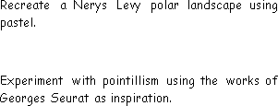

**Science**

**Units:** The Human Body, Seasonal Changes

**Key questions/ experiments:**

Do the oldest children have the longest feet?

What are the main changes each season?

**Mathematics**

**Focus:** Place Value

**Objectives include:**

* Recognise tens and ones
* Use a place value chart
* Partition numbers to 100
* Estimate, order and compare numbers
* Counts in 2s, 5s, 10s and 3s.

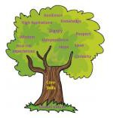

**PE**

Fundamentals

Explore balance, stability, jumping,

hopping, skipping and landing safely.

Forest Schools

Team building skills

**Religious Education**

**Creation: Who Made the World?**

**Religion:** Christianity

**Key Question:** What is the most beautiful thing in the world?

**PSHE**

**Unit:** Being Me In My World

**Overview:**

* Help others to feel welcome.
* Try to make our school community a better place.
* Care about other people’s feelings.

**Music**

**Keeping the Pulse (My favourite**

things).

* Clap and sing a rhythm in time to the pulse.
* Copy rhythms and keep the pulse while playing a rhythm on the instrument.

**Computing**

**Art/Design Technology**

**Art:** Making your mark (Drawing)

* To use a range of drawing materials to mark make.
* To explore tone, form and different techniques to
* represent texture.

**Humanities**

**History** - School/ Toys

**Key Question:** What was life like in the past?

* To know similarities and differences between their lives and those in the past.

**Computing Systems & Networks**

* What is a computer?
* Improving mouse skills
* Use the internet safely