Medical Diet Menus – A Guide for Parents, Guardians & Carers

As your school caterer, our aim is to ensure that children with diagnosed allergies and intolerances are supported and receive a tasty, nutritious, and safe meal. Our nutrition and catering teams work together and follow a robust process, so you can feel reassured that whenever safely possible, an alternative menu will be provided for your child.

Which children will require an alternative menu?
- Children with diagnosed food allergies or diagnosed food intolerances
- Children with Type 1 Diabetes who require a carbohydrate count
- Children with medical conditions requiring a modified menu for example but not limited to: PKU, Cystic Fibrosis, Ketogenic Diets, Renal Function Impairment

Please note:
Children with religious, cultural, or personal requirements or preferences, can choose from the standard menu. You do not need to complete a medical diet request form. This includes but is not limited to vegetarian, pescatarian, vegan and Halal requirements.

Keeping Everyone Safe
We aim to provide meals for as many children as possible, as safely as possibly. We will only provide menus that exclude the whole allergen and not different forms of cooked or raw products, for example we do not partake in the milk ladder or differentiate between raw or baked egg. There is no exception to this. Once we have been informed your child can tolerate an allergen in full, only then will we reintroduce it to their menu.

What happens on theme days?
On theme days, children with allergies to the EU FIC 14 allergens (celery, cereals containing gluten, crustacean, egg, fish, lupin, milk, mollusc, mustard, peanut, tree nut, sesame, soya, and sulphites) will be offered an ‘Allergy Aware’ menu in line with the specific theme day. For children requiring the carbohydrate or fat values of theme day dishes, nutritional information can also be supplied.

The safety of the children we cater for is always our upmost priority. After careful risk-assessment, it has been decided that children with allergies and intolerances outside the EU FIC 14 allergens, will need to choose their favourite meal and dessert from their approved named medical diet menu on these occasions. This includes any combinations of both allergens within and outside the EU FIC 14 allergens. e.g., milk & lentil.

Always fresh, inclusive, tasty, and nutritious
We are aware of how important it is that, despite your child needing a medical diet menu, you feel confident knowing that they are still receiving a balanced and enjoyable lunch. Most of our dishes are made from scratch, using fresh, local ingredients without compromising on taste.

Where possible, the Nutrition Team strive to adapt the dishes already featured on the standard menu to suit your child’s needs. Examples include exchanging pasta for gluten free pasta, utilising various allergen aware pizza options, or using plant-based dairy substitutes. We also have a range of bespoke

medical diet recipes that are not featured on our standard menus, that are suitable for more numerous or complex allergies, never compromising on flavour and nutrition.

How do I apply for a medical diet?
If your child requires a medical diet, please simply follow the steps on the next page to do this via our online portal. To support your request, you must provide medical evidence. This must be in the form of a letter which clearly outlines the child’s food allergies/ intolerances, and must be from a medical doctor, dietitian or Specialist Nurse. We cannot provide a medical diet to a child without medical evidence.
If your child does not require a medical diet, please DO NOT complete a medical diet request form.

- Please click this link: https://orders.lunchhound.co.uk/medicaldiets/request You should be taken to a screen that looks like the below:
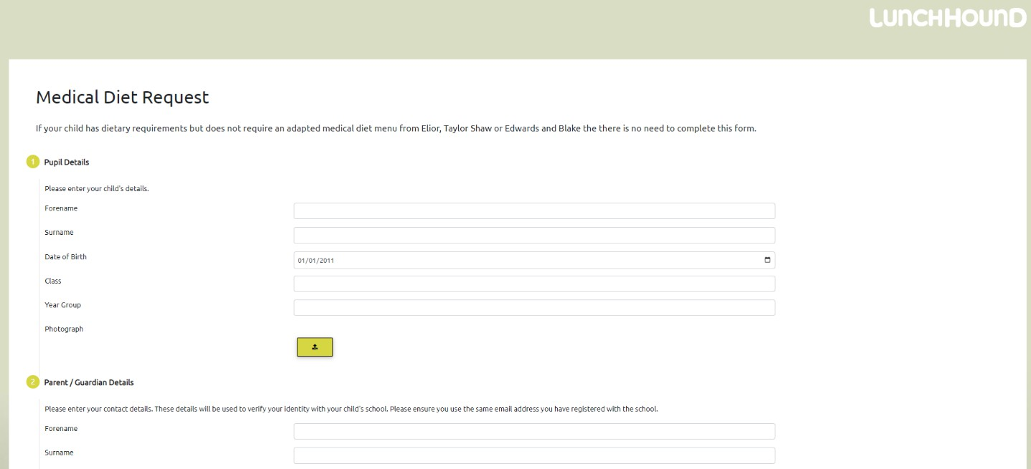

- Please enter your child’s details.

- Next, fill in your contact details. You must provide a valid email address as this will need to be verified before we process your request.

- You then need to inform us which school your child attends, so you will need to know the postcode of your child’s school for the form. Please enter this into the box provided, then click the ‘SEARCH’ button. The search function looks like this:
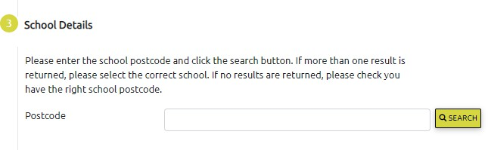

- Once the search has identified the school or schools at the postcode you provided, please check that the correct school is displayed. If more than one school is displayed, please select the correct school from the list.

- Next, please select your child’s allergies from the list. If this request is to add another allergy or additional dietary requirement, please include all existing allergies and dietary requirements as well as any new ones you are adding. If your child has allergies, intolerances or dietary requirements that aren’t listed, please write them in free text box.

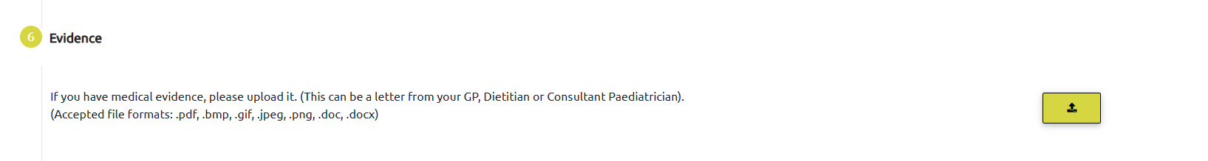
- Medical evidence must be provided to support all medical diet requests. Please upload this by clicking here:

- Please carefully read the Data Storage Consent notice (section 7), then complete the captcha (section 8) and click the ‘SUBMIT’ button to move to the next stage of the process.

- After you have clicked the submit button, the system will generate an email to the email address that you have provided. You must click the link in the email that you have received to verify that the email address is correct. At this stage you will be asked to complete a ‘temporary medical diet meal selection form.’ Please complete this and return this form to your child’s school office, who will pass this onto our catering team. This will ensure we feed your child a safe meal until their named medical diet menu is in place. Until we have received this form, in the interest of your child’s safety, they will be served a plain jacket potato only.

- Once you have verified your email address, the system will notify your child’s school of your request and will ask them to confirm your child’s details.

- After the school have approved the request, you will receive a notification email from ‘noreply@lunchhound.co.uk’ to inform you that your request has been sent to our Nutrition Team for processing.

- When your request has been processed by our Nutrition Team, you will receive a confirmation email. Your child’s school office will be provided with a copy of their menu, which they will pass on to you.

If you require further support with this process, please email support@lunchhound@co.uk

What happens next?
The Nutrition Team will prepare a medical diet menu based on the current standard menu. The allergen information is supplied directly from our manufacturers and suppliers, and products that are labelled with a ‘may contain’ for that allergen will also be excluded. Your child’s menu will include a main meal, vegetarian or vegan option, Halal dish, sandwich option, jacket potato/ rice/ pasta option, dessert, fresh fruit, yoghurt, and salad. Please note that choices may vary depending on your child’s school.

Your child’s menu will normally be created within 2 weeks of receiving all the information. If the menu is more complex, it may take longer, and you will be informed of any delay via email. Once processed, you will receive a copy of your child’s named medical diet menu so you can select which dishes they would like. Please pass these choices onto the school office so they can be given to the onsite catering team. You will receive a new medical diet menu for your child every time the school’s menu changes.

What if my child no longer requires a medical diet?
If your child no longer requires a medical diet and they can eat from the standard menu, you need to click this link: https://orders.lunchhound.co.uk/medicaldiets/request Please complete the data fields then tick the box under the heading ‘Remove Existing Medical Diet’. This will ensure your child is correctly matched to the information in our records and the Nutrition Team can approve the medical diet removal request.

For more information on our school catering, please visit www.elior.co.uk/our-sectors/education.

