
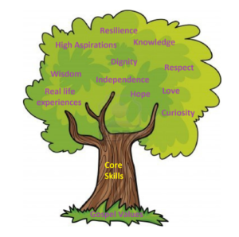

Units: White Rose – The Digestive System
Key questions/ experiments:
What animals hunt and eat each other?
What type of tooth is used for biting food?
What is enamel?
What does digestion mean?
Why is the digestive system important?
What did you observe over time?
Art/Design Technology
Text: Ancient Greece
Writing to Persuade: Travel to Ancient Greece
Writing to Entertain: Greek myth.
Skills:
- paragraphs
- conjunctions
- different sentence types
- consolidation of punctuation
- spelling rules
DT – Digital World – Wearable technology
- Suggest a feature from the virtual micro:bit that is suitable for the product.
- Write a program that initiates a flashing LED panel, or another pattern, on the virtual micro:bit when a button is pressed.
- Identify errors, if testing is unsuccessful, by comparing their code to a correct example.

Unit: Data Handling (weather)
E-Safety: Age restrictions.
- To know that computers can use different forms of input to sense the world around them.
- To know that a weather machine is an automated machine that respond to sensor data.
- To understand that weather forecasters use specific language, expression and pre-prepared scripts to help create weather forecast films.
Unit: Geography
Key Question: Why do people live near volcanoes?
- What are the positive and negative effects of living near a volcano?
- Where are volcanoes located?
- Where is the Ring of Fire located and what is it?
- How do climates have an impact on trade, land use and settlement?
Unit: Changing Me
Overview and Key Questions:
My changing body and feelings
What is self-image?
Coping during times of change
My changing ways of thinking
Managing my changes in mood
Moving forwards into my next year of education

Unit: Kingdom of God
Religion: Christian World Views
Key Question: When Jesus left, what was the impact of Pentecost?
Religious Education
Unit: Romans
Key Skills:
-Learn a new song, singing in time and in tune while following the lyrics.
-Identify motifs and play a repeated pattern on a tuned instrument.
-Create and performing a motif, notating it with reasonable accuracy.
-Transpose their motif, using sharp or flat notes where necessary and change the rhythm.

Year 3 Curriculum Overview – Summer 2

Units: White Rose – Mass and Capacity, Money and Time
Objectives include:
- Measuring in g, kg, l, ml
- Comparing mass
- Converting pounds and pence
- Adding and subtracting money
- Roman numerals
- Hours, days, months, years
Computing
PSHE
Dodgeball: Develop throwing at a target. Develop dodging to avoid being hit. Develop catching skills. Apply skills to a tournament.
Athletics: To develop stamina for running. Develop power and speed in springing. To develop jumping distance. Develop throwing a distance.

Physical Education
English
Science
Mathematics
Humanities
Music

