Year 1/2 Spring 2 Curriculum Overview

**English**

**Text:** The Lighthouse Keeper’s Lunch

**Skills:**

* Expanded noun phrases
* Imperative verbs
* Sentence types
* Commas for a list
* Embedding skills focused on in the previous half term.

**Mathematics**

**Focus:** Multiplication and Division

**Objectives include:**

* Recall and use multiplication facts for the 2, 5 and 10 times table.
* Show that multiplication of numbers can be done in any order (commutative) but that division can not.
* To write multiplication and division number sentences using the correct symbols.
* Solve problems using arrays, repeated addition and mental methods, including problems in contexts.

**PSHE**

**Unit:** Healthy Me

**Overview:**

* Healthy Choices
* Lifestyle
* Motivation

**Religious Education**

**Unit:** Christianity - God

**Key Question:** What do Christians believe God is like?

page1image23063488

**Author for this half term;** Julia Donaldson

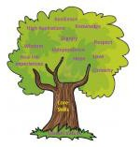

**PE**

Invasion Games

Master basic movements including

running, jumping, throwing and catching.

Gymnastics

Developing balance agility and

co -ordination.

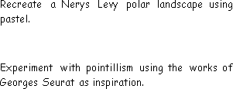

**Science**

**Unit:**  Living Things and their Habitats

Why do we care for plants and animals?

**Key questions/ experiments:**

What different habitats are there on planet

Earth and what lives in each habitat?

Unit: Programming – Scratch Junior

* To know that the character is controlled by programming blocks.
* To know that loops are created by repeating instructions.

**Computing**

**Art/Design Technology**

Unit: Cooking and Nutrition

What am I worth?

* Understand what makes a balanced diet.
* To know the five different food groups.
* To know that ingredients make up a recipe.

**Music**

**Unit:** Musical symbols

Read symbols representing high and low sounds.

Demonstrate an awareness of pitch, rhythm and dynamics.

**Humanities**

Unit: Great Explorers

Is it okay to try and give up?

**Key Question:**

How have explorers changed the world?