
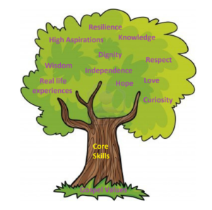

Units: White Rose – The Digestive System
Key questions/ experiments:
What animals hunt and eat each other?
What type of tooth is used for biting food?
What is enamel?
What does digestion mean?
Why is the digestive system important?
What did you observe over time?
Art/Design Technology
Text: Ancient Greece
Writing to Persuade: Travel to Ancient Greece
Writing to Entertain: Greek myth.
Skills:
- paragraphs
- conjunctions
- commas
- fronted adverbials
- speech
DT – Digital World – Wearable technology
- Suggest a feature from the virtual micro:bit that is suitable for the product.
- Write a program that initiates a flashing LED panel, or another pattern, on the virtual micro:bit when a button is pressed.
- Identify errors, if testing is unsuccessful, by comparing their code to a correct example.

Unit: Data Handling (weather)
E-Safety: Age restrictions.
- To know that computers can use different forms of input to sense the world around them.
- To know that a weather machine is an automated machine that respond to sensor data.
- To understand that weather forecasters use specific language, expression and pre-prepared scripts to help create weather forecast films.
Unit: Geography
Key Question: Why do people live near volcanoes?
- What are the positive and negative effects of living near a volcano?
- Where are volcanoes located?
- Where is the Ring of Fire located and what is it?
- How do climates have an impact on trade, land use and settlement?
Unit: Changing Me
Overview and Key Questions:
Understanding personal characteristics
Understanding the process of having a baby
Understanding how bodies change
Understanding menstruation
Understanding changes
Preparing to move classes
Unit: Kingdom of God
Religion: Christian World Views
Key Question: When Jesus left, what was the impact of Pentecost?
Religious Education
Unit: Romans
Key Skills:
Learn how to play together as part of an ensemble
Secure reading musical notation.
Increase knowledge in the length and pitch of notes
Understand rhythm.

Year 4 Curriculum Overview – Summer 2

Units: White Rose – Shape, statistics, position and direction
Objectives include:
- Understanding different angles
- Naming the properties of polygons
- Securing the 4 mathematical operations
- Interpreting graphs
- Coordinates
Computing
PSHE
Dodgeball: Develop throwing at a target. Develop dodging to avoid being hit. Develop catching skills. Apply skills to a tournament.
Athletics: To develop stamina for running. Develop power and speed in springing. To develop jumping distance. Develop throwing a distance.

Physical Education
English
Science
Mathematics
Humanities
Music

